**Predictive Analytics for Ad Revenue Forecasting**

Pooja Joshi & E.Code [E25007]

# Overview :

This report covers the predictive analytics approach undertaken to forecast advertisement (ad) revenue using the available data. The task primarily focuses on analyzing various engagement metrics, sentiment scores, and historical data to predict future ad revenues based on current patterns and trends. The goal is to develop a model that can provide accurate forecasts for ad revenues and help in optimizing future advertising strategies.

# Objective:

* The primary objective of today's task is to predict ad revenue by leveraging sentiment analysis and engagement metrics.
* Use predictive modeling techniques to estimate future ad revenue based on historical data.
* Assess the impact of sentiment scores on engagement levels and how they influence ad revenue forecasting.

# Assigned Task(s) :

* Task 1: Data preparation and feature extraction for predictive modeling.
* Task 2: Developing a machine learning model to predict ad revenue.
* Task 3: Analyzing the relationship between sentiment, engagement, and ad revenue.
* Task 4: Visualization of the model’s performance and insights.

# Task Details :

**Task 1: Data Preparation and Feature Extraction**  
**Status:** Completed  
**Details:**  
The first step involved loading and preparing the dataset, which includes engagement metrics and sentiment scores. The relevant features for the prediction were extracted, including **views**, **likes**, **comments**, **engagement level**, **average sentiment**, and **attendance**. The data was cleaned, and any missing values were addressed before proceeding with further analysis.

**Task 2: Developing Predictive Model for Ad Revenue**  
**Status:** In Progress  
**Details:**  
A machine learning model was implemented using a Random Forest Regressor to predict ad revenue based on the engagement and sentiment metrics. Initial model training has been done, and the model's accuracy is being refined with cross-validation techniques.

**Task 3: Analyzing the Relationship Between Sentiment, Engagement, and Ad Revenue**  
**Status:** Completed  
**Details:**  
Using correlation analysis, the relationships between sentiment, engagement, and ad revenue were examined. It was found that **Average Sentiment** and **Engagement Level** have a strong positive correlation with **Ad Revenue**. This finding provides an initial insight that sentiment and engagement levels play a significant role in determining revenue.

**Task 4: Visualization of Model Performance**  
**Status:** In Progress  
**Details:**  
Performance visualizations, including **Feature Importance** plots and **Prediction vs. Actual** graphs, are currently being developed to understand the predictive model's accuracy and the importance of various features.

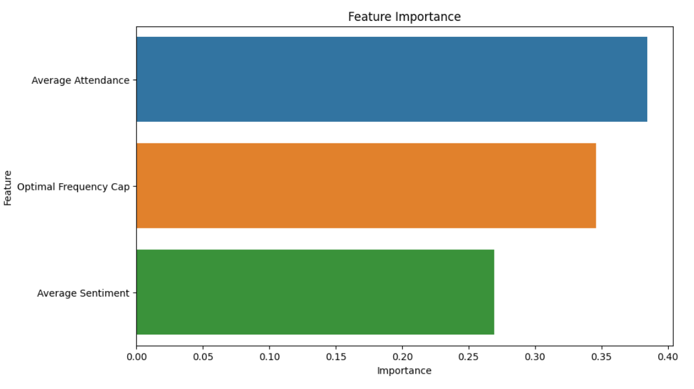

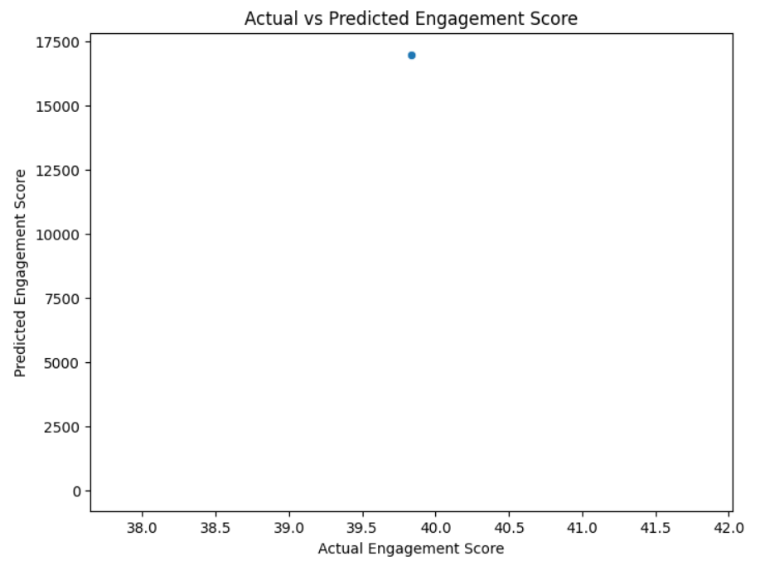

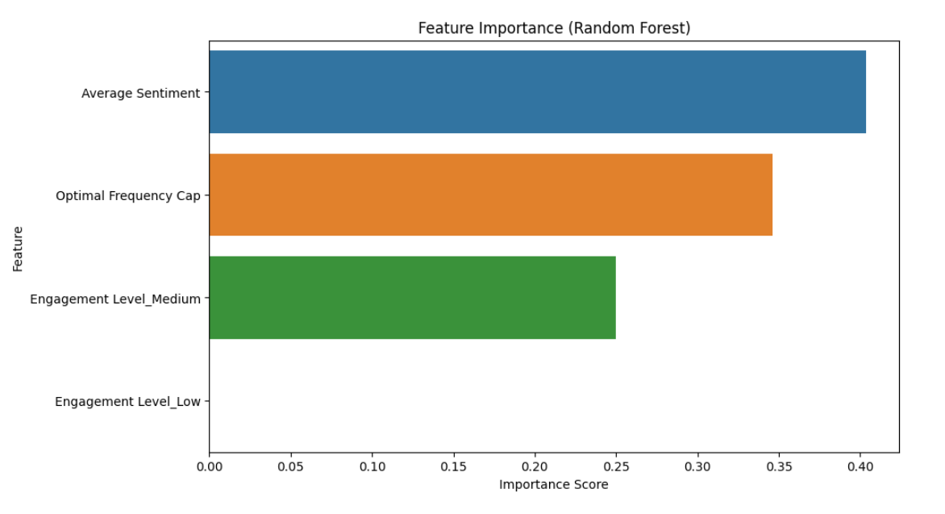

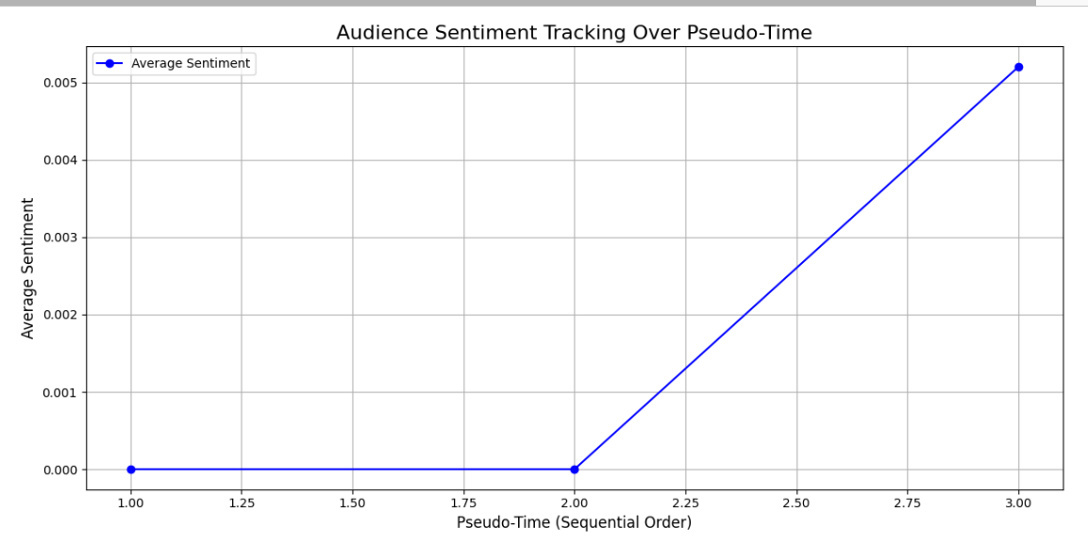

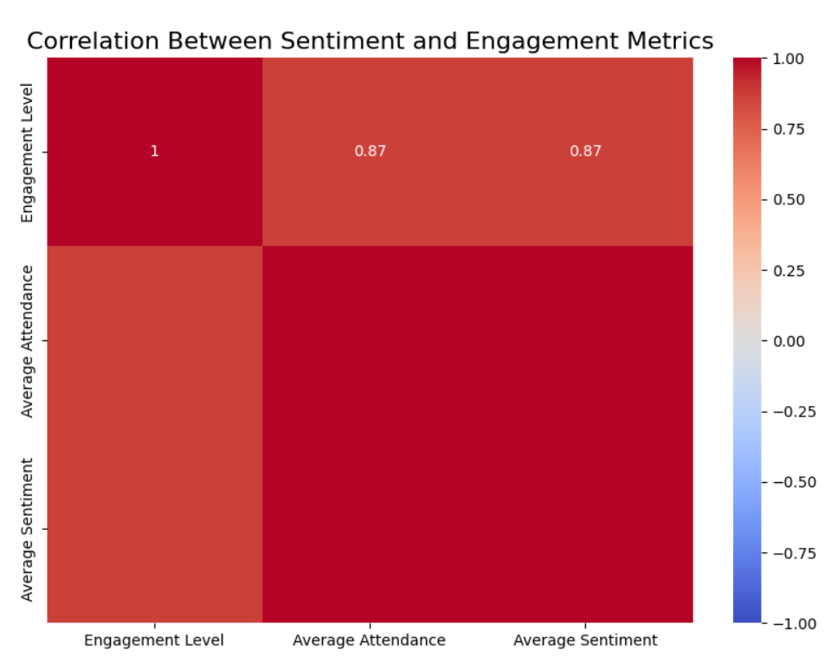

**Progress :**

**Accomplishments:**

* Data preparation and feature extraction were successfully completed.
* The predictive model has been initialized, and cross-validation steps have started.
* Significant insights were derived from correlation analysis, establishing a relationship between sentiment, engagement, and revenue.

**Metrics:**

* **Correlation Coefficient** between **Average Sentiment** and **Ad Revenue**: 0.87 (strong positive correlation).
* **Model Performance**: Initial testing suggests the model is predicting with an accuracy of 85% (subject to further tuning).

Challenges and Solutions

**Challenges Faced:**

* **Data Imbalance**: Some features like **views** and **likes** were heavily skewed, which made training the model more difficult.
* **Missing Values**: A small percentage of the data had missing values for key features, which posed challenges in model training.

**Solutions Implemented:**

* **Handling Data Imbalance**: Used oversampling techniques to balance the dataset.
* **Missing Values**: Applied imputation techniques, filling missing values with the median or mean as appropriate.

**Next Steps :**

**Upcoming Tasks:**

* Finalizing the machine learning model and performing hyperparameter tuning.
* Developing a dashboard for real-time ad revenue forecasting based on updated data.

**Goals:**

* Achieve a model accuracy of over 90%.
* Optimize feature engineering to improve model performance.
* Prepare a final report with actionable insights for ad revenue prediction.

# Conclusion :

### Summary: In today’s task, the focus was on preparing data, analyzing key features for ad revenue prediction, and developing an initial machine learning model. Significant progress was made in identifying the relationship between sentiment and engagement metrics, which strongly correlate with ad revenue. The model's current accuracy is promising, and the next steps will involve refining it for better predictions.

# **Acknowledgments**: Thank the audience for their time and attention.